# Lab_06_01 -- Chapter 06 – Person Continued

## Lab Description:

Expand the Person class you created in Lab_05_02. Create a PersonDemo.java class to test each piece of functionality as you modify the Person.java class.

Start with the instructions on pg 475, #10 (below).

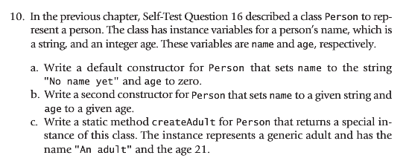

Next, complete the Person class by using the instructions on pg 479, #6 (below).

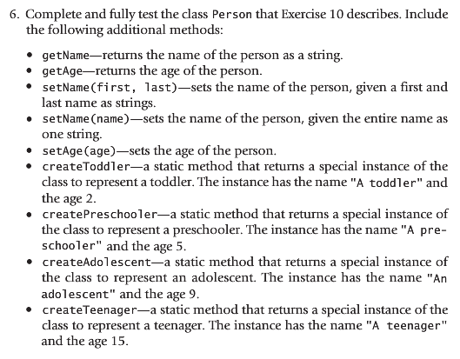

## Lab Requirements:

1. The class should be named Person.java
2. Include a static instance variable in the Person class, which keeps track of the number of People created
   1. Increment this value were appropriate within the Person class
3. You should make one of your constructors the “master” constructor, as we discussed in class.
4. Include a PersonDemo.java class showing how you tested your constructors and static methods
5. Create a toString() method that describes your Person
6. Write a paragraph explaining what static instance variables and static class methods are. Discuss how they are both used. Include this with your lab submission.
7. Use Java formatting conventions
8. Use comments where appropriate
9. Submit your Person.java and PersonDemo.java to Blackboard
   1. Remember, your submitted source code must compile or a zero will be given